- Now, I am facing one issue that I stopped the EC2 last night to avoid any unnecessary cost, but when I restart the server (EC2) my Public IPv4 changed and now when I open it there is no website instead there is a welcome page of nginx. What to do?? how to resolve it and get my website back??

Two Problems — Both Easy to Fix! 😊
Nginx welcome page = Your app is not running. Nginx is working but has nothing to forward to. Just start your app again!

✅ Step 1 — SSH Into Your Server With New IP
Get your new IP from AWS Console → EC2 → Instances → Public IPv4 address
Then connect:
ssh -i "C:\Users\abdul\Desktop\grocery-key.pem" ubuntu@NEW_IP_HERE

✅ Step 2 — Start Your App With PM2
cd ~/AWS-Grocery-app
pm2 start server/index.js --name "AWS-Grocery-app"
pm2 save

✅ Step 3 — Visit Your New IP in Browser
http://NEW_IP_HERE
Your grocery app should be back! 🎉

✅ Permanent Fix — Avoid This Problem Forever
Every time EC2 restarts, IP changes. Fix this with an Elastic IP — a permanent IP that never changes:
- AWS Console → EC2 → Elastic IPs (left sidebar)
- Click "Allocate Elastic IP" → Allocate
- Select it → Click "Associate Elastic IP"
- Choose your EC2 instance → Associate ✅
Now your IP never changes even after stopping/starting! 🎯
⚠️ Elastic IP is free only while your EC2 is running. It charges ~$0.005/hr if EC2 is stopped — so release it when not needed.

require('dotenv').config() this comes at the top of the file so it can read your .env file. For e.g. if it is the email.js file then my email.js file can read the .env for user credentials
npm install dotenv remember to install dotenv on the server to enable reading .env file
GENERAL ERRORS THAT OCCURRED DURING THE DEPLOYMENT WITH THEIR SOLUTION:
Deployment Errors — Master Reference Table 🎓
# | Error | Why It Happened | Solution | Lesson Learned
1 | SSH: Connection timed out | Port 22 (SSH) was not open in AWS Security Group | AWS Console → Security Group → Add Inbound Rule → SSH → Port 22 → Anywhere | Always open port 22 first before even trying to connect
2 | EADDRINUSE: port 3000 (first time) | A previous node process was manually run and still holding the port | kill -9 $(lsof -t -i:3000) then restart | Never run node manually AND pm2 at the same time
3 | PM2 shows online then immediately errored | PM2 restarted the app, but old zombie node process still held port 3000 — new instance couldn't bind | sudo killall -9 node → pm2 delete all → pm2 start server/index.js directly | Always killall node before starting PM2 fresh
4 | pm2 start npm -- start caused port conflict loop | npm spawns a child node process — creates 2 processes, PM2 loses track, port isn't released on crash | Use pm2 start server/index.js directly instead of going through npm | Always start PM2 with the JS file directly, never through npm
5 | App running fine but PM2 showed errored | App was running as a manual node process — PM2's own copy couldn't start because port was taken | sudo killall -9 node → let PM2 be the only one starting the app | One owner rule — either PM2 runs it OR you run it manually, never both
6 | Port 3001 also showed EADDRINUSE after switching | Previous manual node server/index.js was still alive in background holding port 3001 | sudo fuser -k 3001/tcp + sudo killall -9 node | Before switching ports, always kill ALL node processes first
7 | ln: failed to create symbolic link: File exists | Nginx symlink was already created from a previous attempt | Skip ln command — it's already linked. Just run nginx -t and restart | Nginx symlink only needs to be created ONCE — error means it's already done ✅
8 | Created wrong symlink (grocery-app instead of AWS-Grocery-app) | Copy-pasted wrong name from guide | sudo rm /etc/nginx/sites-enabled/grocery-app then recreate with correct name | Always match your exact project folder name — copy it from ls output
9 | Browser forced HTTPS, IP didn't support it | Browsers auto-redirect to HTTPS but raw IPs can't have SSL certificates | Type http:// explicitly OR get a free domain + Let's Encrypt | SSL/HTTPS only works with domain names, never raw IPs
10 | Nginx welcome page after EC2 restart | EC2 stopped overnight — PM2 process list was lost, app wasn't running | SSH in with new IP → pm2 start server/index.js → pm2 save | After every EC2 restart, manually start PM2 again OR use pm2 startup to auto-start
11 | IP changed after EC2 restart | AWS assigns a new dynamic public IP every time EC2 stops/starts | Allocate an Elastic IP in AWS and attach it to your instance | Elastic IP = permanent IP that never changes — set it up once at the start

🧠 The 3 Golden Rules You Must Never Forget:
Rule 1 — Port Discipline: Before starting your app, ALWAYS run sudo killall -9 node to ensure no zombie processes exist.
Rule 2 — PM2 is the Boss: Once PM2 is managing your app, NEVER run node server/index.js manually — let PM2 be the only owner.
Rule 3 — Elastic IP First: Before doing ANY deployment work, attach an Elastic IP so you never lose your address after a restart.

- app.listen() reserves the port exclusively in the OS
- Two app.listen() on same port = instant crash
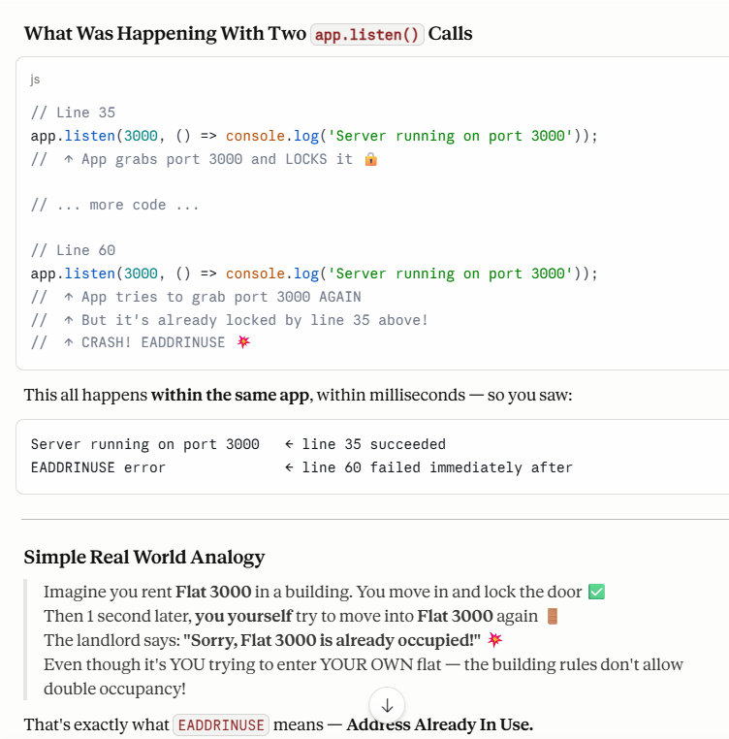
The fix is simple, to only use one app.listen() in the file.
One app → One port → No conflict → No crash
You almost never need multiple ports in a simple app. Your entire grocery app — cart, orders, email, products — all runs on one single port because they're all part of one Express app.
Multiple ports are only used when you have completely separate servers — like a separate frontend server AND a separate backend server running independently. That's a much more advanced setup.
The One Golden Rule:
One Express app = One app.listen() = One port, written once at the bottom of index.js only.

